 | Leapers’ Hill  Learning the true story of Leapers’ Hill  Address - Sauteurs, St. Patrick’s  Visiting Details Other Attractions in Area - Free admission - Town of Sauteurs, Grave of Walter Noel (see Info on Sickle-Cell below)  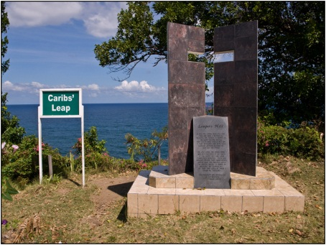 |  | Field Trip Guide  Grenada National Museum: Teacher Kit  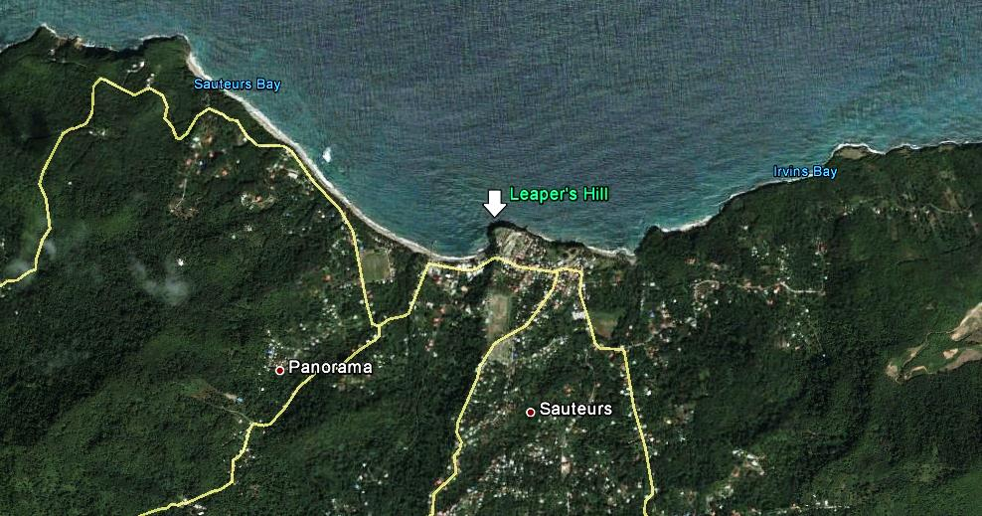  Adventures Outside the Museum

 | Before You Visit  The Legend of Leapers’ Hill  Overview  Students will learn about the “legend” of Leapers’ Hill, as told by the 1660s Anonymous History of the Island of Grenada in America, 1649-59. Following repeated battles with the Island Caribs, the French sought ways to rid them from Grenada. That chance came when an Island Carib named Thomas revealed the place where many Island Carib men assembled. On the 30th of May, 1650, the French made their way to Duquesne and waited for nightfall. After confirming that the men were there, the French decided to attack. With their guns loaded and bayonets drawn, the French fell on the Caribs. With no other escape around 40 Island Caribs jumped over the cliff later called le Morne des Sauteurs to a watery grave. |  | At A Glance  Grade Levels - 4th + - Extension Activities for Secondary Forms 1+  Duration - Pre-Visit: 20 minutes - Visit: 20-30 minutes - Post-Visit: 15 minutes  Topics - Narrative history - Amerindian resistance against European colonialization - Grenadian local history  Materials - 5-6 copies of the Story of Leapers’ Hill Handout (enough for student groupings of 4-5) - At the Site: Exercise books and pencils for each student  Museum Exhibit Tie-Ins - European Invasion Displays: French Settlement of 1649 “Bloody confrontations”
Background
The Historie de l’isle de Grenade en Amérique, 1649-59 is an anonymous, 17th century manuscript that details the first ten years of the French in Grenada and their battles with the Island Caribs for control of the island. It is believed to be written by Father Benigne Bresson who was a missionary in Grenada between 1656 and 1659. Amazingly, this manuscript went unknown to historians for over 200 years until a French librarian came across it in 1872. The Jesuit school where he found it, however, has since closed and the original document disappeared. But 100 years later, in 1972, a copy transcribed by the librarian was discovered in a Paris bookstore by a visiting professor from the University of Montreal. Realizing its significance, he bought the book and sent it to Jacques Petitjean Roget, a Caribbean historian in Martinique. Together they investigated the document’s authenticity and history. Petitjean Roget than translated it to English and sent a copy to the Grenada National Museum. Historians believe that the information in this manuscript is more accurate than that written by later authors. Because of its obscurity, however, many authors continue to be unaware of its existence. Today you will read the Leapers’ Hill story as recorded in that document.

Objectives
SWBAT retell the true story of Leapers’ Hill

Procedure
- Tell students they’re going to read the Leapers’ Hill story described in the “Anonymous History”
- Make a KWL chart on board. Under K, record what students know about what happened at Leapers’ Hill. Under W, ask them what they want to learn from the story.
- Read the Background information aloud to the class.
- Split the class into groups of 4-6 students, and give each group a copy of the story.
- Have the groups read the story aloud in a round-robin format. Each student will read 1 paragraph and the pass until story is finished. They should read the story twice.
- Have students come back to whole group. Ask: Why did the French attack the Caribs? Who told the French that it was a good time to attack? Why did he tell them that?
- Return to KWL chart; ask students what they learned from the story. Did they look back at the W column and learn what they wanted to learn? If not, how could they get that information? Look back at K, do they have to revise what they thought they knew about the Leapers’ Hill story.

Debriefing
Have students point out the main differences between what they thought they knew about Leapers’ Hill and what they learned.

Adaptations for Struggling Students
- Have students work in pairs or small groups and assign a strong writer as the group’s recorder. This will take the pressure off of writing while still allowing struggling writers to contribute their ideas.
- Give adequate ‘think time’ when asking questions. Some students need extra processing time to formulate their answers.

At the Site

Using Narrative to Tell History

Overview

After having read the true story of Leapers’ Hill (Pre-Visit Activity), students are going to create a narrative to share what happened while in the same setting that the story took place.
Objectives

SWBAT use their background knowledge of Leapers Hill to respond to a journal prompt.

Procedure

Gather the class at the Leapers’ Hill monument. Ask a student to retell the story, as they learned from the Pre-Visit activity.

Tell students they’ll have 10 minutes to respond to a journal prompt in their exercise books.
Pretend you are a Carib at the party. You’re having a great time, when all of the sudden you see armed French soldiers running towards you.
Students can choose:
a) Write what they see, think, feel, and do as the soldiers attack; or,
b) Sketch the scene they imagine as the French soldiers attack and prepare an oral narrative (spoken story) to go along with it.

Have one or two students share their work and tell their versions of the narrative.

Debrief

Back in class or on the bus, have students share their drawing or journal entry with their neighbor and discuss.

Extension

“Communal” suicide was not uncommon amongst Amerindians. The Spanish had seen this happen from their earliest attempts to enslave the Taino in Hispaniola. As Dr. Lennox Honeychurch has explained:

“Kalinago society was one where the world of the here and now and the world of the spirit interwove with each other like the fibers of a basket. The shaman practicing his ‘spells' and consuming local narcotics travelled out of this world and returned with solutions to the problems of the present. Armed with this perception of continuous life in different zones of reality, the Kalinago were more than a match for Europeans. Western domination relied on the concept that the enslaved person would do everything possible, including forced labour, to continue living regardless of the conditions. Faced with a society that was prepared to die rather than surrender, the colonizers conquered land but found it impossible to control the living people.” (Honeychurch, 2002). Discuss this sentiment.

Other activities in the Sauteurs Cemetery (for Secondary School students):
Have students search for the grave of Walter Clement Noel. Once someone finds the correct grave (watch the dates, there is more than one Walter Noel), gather the class and read the Sickle-Cell handout.

Additionally, the St. Patrick’s Anglican Church was built between 1829 and 1831. It is the oldest Anglican church in St. Patrick and sits on the site of a previous palisade fort and coastal battery. The St. Patrick’s Roman Catholic Church was built between 1841 and 1851. It is the oldest Catholic church in St. Patrick’s, and was used as a reference to locate the Leapers’ Hill precipice (early accounts note that the Catholic Church was built near the site). However, the original RC church (1664-1795) stood where the police station and courthouse is today. It had been confiscated by the Anglicans in 1784 and was subsequently burned down during Fedon’s Rebellion (1795). Thus, the RC church noted in historical accounts was not located where the present one is. Might the smaller cliff north of the police station be the actual location of Leapers’ Hill?

In 1994, archaeologists located an Amerindian site in St. Patrick’s Bay, just west of Leapers’ Hill that dates to the colonial era. It’s likely the same village attacked by the French in 1650. If this was where the attack began, it’s likely that the current location of Leapers’ Hill is the correct one. Additionally, in 1613 Spanish sailors reported trading with Amerindians at this same location (see figure below).

After Your Visit
General Reflection/Wrap-Up Questions
- Why did the French attack the Island Caribs?
- Why weren’t they all able to live peacefully in Grenada?
- Was the Carib’s Leap event the end of the Island Caribs in Grenada?

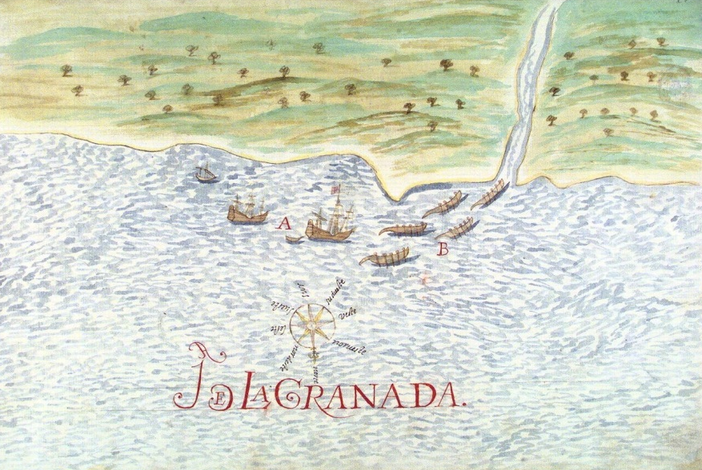
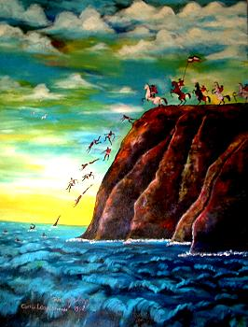
A 1614 sketch by Nicolas de Cardona depicting Spanish ships meeting Amerindian canoes at either Irvin’s Bay or Sauteurs Bay itself
Painting of the event by artist Freddy Paul

