 | Duquesne Beach Petroglyphs  Understanding symbols and their meaning to the people who created them  Address - Duquesne Beach, St. Mark’s (southern end of beach)  Visiting Details Other Attractions in Area - Free admission - Car park at corner shop - Leaper’s Hill (below) |  | 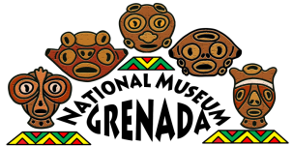  Field Trip Guide  Grenada National Museum: Teacher Kit  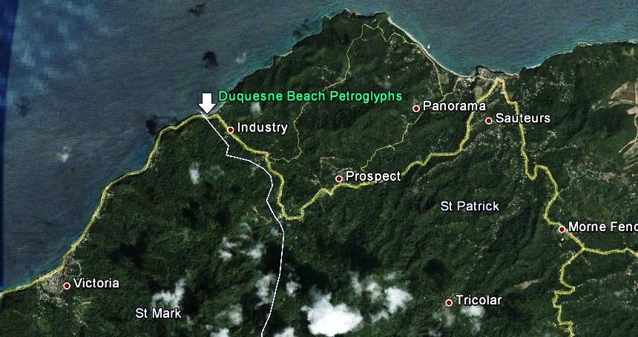  Adventures Outside the Museum

 | Before You Visit  Cultural Symbols  Background  Symbols are representations of people, places, things, and ideas. The purpose of a symbol is to communicate meaning. For example, a red octagon may be a symbol for "STOP". Likewise, written language represents spoken language, which in itself conveys meaning about the world. The word “tree” is not a tree itself- it simply represents something in reality and achieves this purpose by conveying the image of a tree in your mind. Personal names are symbols representing individuals. On rocks throughout the Caribbean, Amerindians carved permanent symbols that still exists today. Their meanings are unknown, as their culture has been  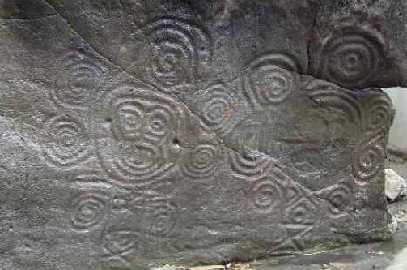 |  | At A Glance  Grade Levels - 4th + - Extension Activities for Secondary Forms 1+  Duration - Pre-Visit: 30-40 minutes - Visit: 20-30 minutes - Post-Visit: 15 minutes  Topics - Cultural symbols - Petroglyphs - Archaeology and history  Materials - Pictures of other petroglyphs (Handout) - Symbols worksheet - At the Site: Exercise books and pencils for each student  Museum Exhibit Tie-Ins - Amerindian Exhibit Displays: Prehistoric Grenada ‘Heritage Trail’ Map; - What is Archaeology?
lost in many ways. Archaeologists and others that have studied them believe most to be of religious/spiritual importance (images of gods, protection from evil spirits, etc.), but we don’t know for sure. Scientists call these images "petroglyphs" [>petro=rock, >glyph=symbol] but many people just call them "rock art." The term "Carib stone" is used as well, but the word Carib (more correctly, Island Carib) refers to the people living in the Lesser Antilles during European colonization- not necessarily the same ones who created the stones. We simply do not know what these people called themselves, so archaeologists use the general term “Amerindian.” At some sites, pottery has been found associated with rock art, and thus specific ceramic types (e.g. Saladoid, Suazoid, Troumassoid, etc.) can indicate a specific time period.

Lesson objectives
SWBAT make a connection between the petroglyphs at Duquesne beach (and elsewhere) and the symbols we use in modern society.

Procedure
- Explain to students that they’re going to look at symbols from the past and present. Ask students to define “symbol” and give an example of ones we use at school or in the country. Discuss.
- Read the Background Information to the class.
- Display the worksheet on the board, or pass out copies (if available).
- Explain Section 1 and clarify any concepts students are unfamiliar with. Give them 5 minutes to complete this section. Discuss answers.
- Explain directions for Section 2- students can work in pairs. Given them 5 more minutes.
- Discuss students’ answers. When done, reveal the true meaning of the image, and read the explanation on the Answer sheet.
- Display images of other petroglyphs (attached) and discuss their possible meanings. Remind students that they were created by a very different culture, so it’s difficult to understand their meaning.

Adaptations for Struggling Students
- Have students work in pairs or small groups and assign a strong writer as the group’s recorder. This will take the pressure off of writing while still allowing struggling writers to contribute their ideas.
- Give adequate ‘think time’ when asking questions. Some students need extra processing time to formulate their answers.

At the Site

What Do You See?

Overview

We are going to spend a few minutes on Duquesne beach, looking at the petroglyphs, drawing what you see, and discussing their possible meanings.

Background Information

Duquesne beach is good place to get up close to a number of ancient petroglyphs. A petroglyph is a symbol engraved into rock. In the Caribbean, they represent an unanswerable puzzle for archaeologists. There was no system of writing before Columbus, so all we have to go on are the interpretations of early Europeans who wrote down what they understood. We can also compare rock art across the Caribbean and Amazon to see similarities. But the meanings we assign may have nothing to do with the original meaning.

The first, most obvious point of interest on Duquesne Beach are the twin faces side-by-side. Some archaeologists have supposed that each represents the radiant head of the rainbow serpent in Amazonian mythology. They appear here as twins, a common element in New World mythology. However, the combined meaning of twin rainbow serpents (if that is what they are), is unknown. On the bottom of the southern side of the same stone, more carvings can be seen (one is quite similar to the beach petroglyph just south of Gouyave). On the next stone to the South are the indented lines of a work stone- perhaps the same work stone used to sharpen the carver's tools! (Remember, they didn't have metal chisels.)

The name Duquesne was given by the French to the "Caribe" chief in the area. In 1994, archaeologists found evidence of a prehistoric site on the plantation to the West, but it's not known if this was associated with the rock drawings. Archaeologists who study petroglyphs in the Lesser Antilles believe this style of petroglyph to be from the Suazoid period (900-1200 AD). As with other petroglyphs on the island (excepting Mt. Rich), the beach location could represent the boundary between the world of the Sea and world of Land. Rock Art throughout the Caribbean is different from the images seen on Amerindian pottery, though a few figures such as bats (men) and frogs (women) do show up on both.

Objectives

SWBAT examine a real petroglyph, first hand, and create a sketch of it.

Procedure

Gather the class in front of the Petroglyph (south end of the beach).

Ask someone to point out the two biggest drawings

Have students make some educated guesses about what they think it could mean

Read the Background Information aloud to the class

Give students 5 minutes to make a quick sketch of the petroglyphs

Have a few volunteers share their drawings

Give them another 5 minutes to explore for other petroglyphs in the immediate area (sketch them if they find any). Note: if the tide is low, you can find others in the rocks to the south.

If you completed the pre-visit lesson

Ask a student to summarize what they learned about symbols already. How can they compare the Maya monkey hieroglyph to the Duquesne Beach petroglyphs? (Answer: We can’t understand either of them without more information about the society that created it. Just as a monkey is a common thing, this image could represent something common as well. It could also mean something nobody has thought of yet!)

Debriefing

Back in class or on the bus, have students look at each other’s drawings to notice similarities and differences in what they each saw. If you did not do the pre-visit lesson, ask a student now to summarize what they’ve learned about symbols and petroglyphs.

After Your Visit
Extensions/Post-Visit Activities
- Imagine what life was like in Grenada 1000 years ago, long before the modern world. Now write a back-story to the Duquesne petroglyphs. Who and what are they? Are they twins? Are they married? What is something that happened to them in their life?

- Research on the internet to learn about symbolism, language, and culture. A good starting point is in semantics, the word used to describe meaning in language. A short video on this can be found here: http://www.youtube.com/watch?v=9ZDkp8dUWyw

General Reflection/Wrap-Up Questions
- What is a petroglyph?
- Who created the Duquesne petroglyphs? Why?
- How do we use symbols in modern life?
- Compare and Contrast our use of symbols to ancient uses.

