 | Pearls Airport  Student Activity Handout: Images of Pearls |  | Amerindian Heritage  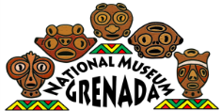  Grenada National Museum: Teacher Kit
Artifacts at Pearls
What do you think each artifact is, and what was it used for?

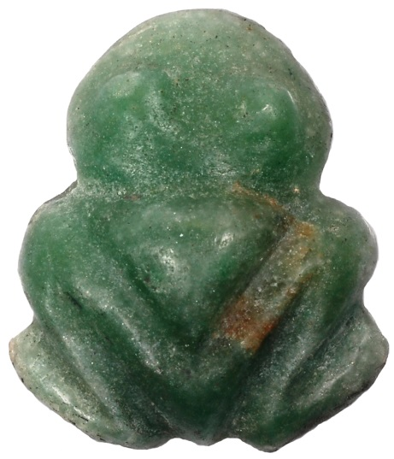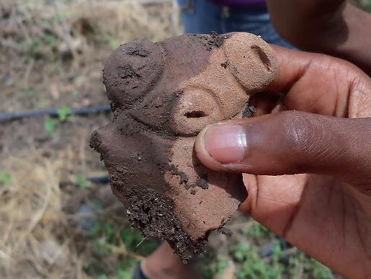

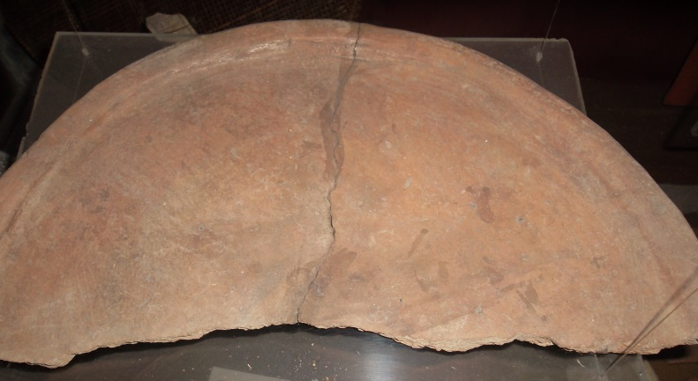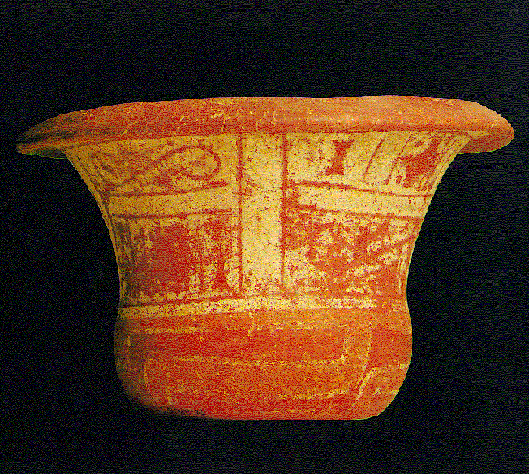

Photos 1 and 4 are similar to specific artifacts found at Pearls, though not the originals.

