 | Amerindian Foods  Handout: Photos of New World foods |  | Amerindian Heritage  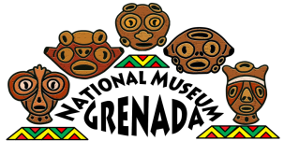  Grenada National Museum: Teacher Kit
Here are photos of some common foods that were eaten by Amerindians in the New World.
What can you tell about them by how they look?
Would they be a good food source?
Do you eat any of these foods today?
Manioc/Cassava  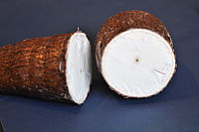 | Beans  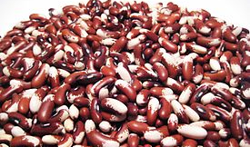 | Maize/corn  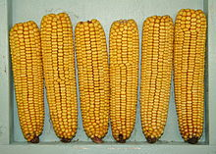
Sweet potatoes  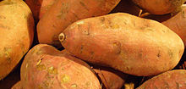 | Peppers  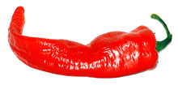 | Palm nuts (variety)  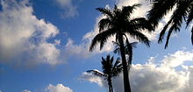
Yams (and other starchy tuber crops)  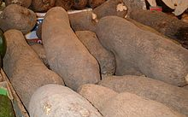 | Peanuts  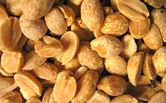 | Guava  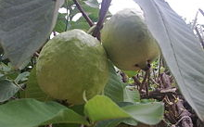
Squash  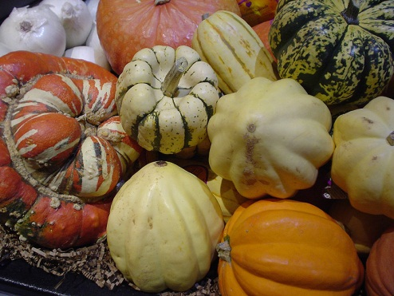 | Pineapple  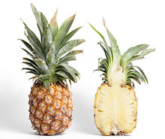 | Papaya  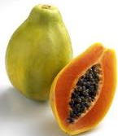
All images retrieved from en.wikipedia.org

