 | Amerindian Migrations  Handout: Maps of Migration Routes (by period) |  | Amerindian Heritage  Grenada National Museum: Teacher Kit

Possible routes to the New World, with earliest migrations over Beringia from Asia, beginning approx. 22,000 BCE
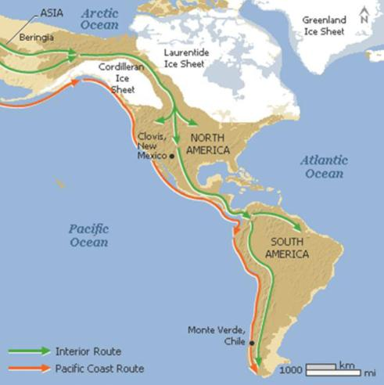

Major migration paths into the Caribbean, beginning approx. 3600 BCE.
