 | Pearls Airport  Discovering archaeological artifacts found at Pearls  Address - Pearls, St. Andrew  Visiting Details - Free admission; Explore land area opposite air strip |  | Field Trip Guide  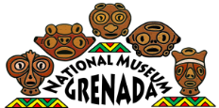  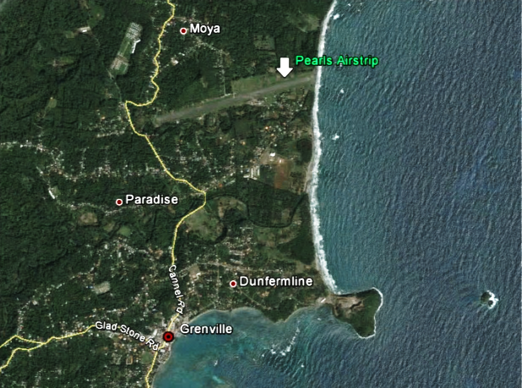  Grenada National Museum: Teacher Kit  Adventures Outside the Museum

 | Before You Visit  The Legend of Leaper’s Hill  Overview  Students will learn about artifacts found at Pearls and make inferences about what Amerindian society was like.  Background  The Pearls airport presents two fascinating features of Grenada's history: its early Prehistory and the American Intervention in 1983 [Note: This lesson will only discuss the Prehistory aspect].  The area around Pearls may have been known as an Amerindian site before the airport, but it wasn't until the airport was built that it became widely known. When the construction crews bulldozed the area flat in 1941 (notice the "push-piles" on the sides of the airstrip) they found Amerindian artifacts all over the place. It turns out that Pearls was an enormous, thriving port in prehistory |  | At A Glance  Grade Levels - 4th + - Extension Activities for Secondary Forms 1+  Duration - Pre-Visit: 20 minutes - Visit: 20-30 minutes - Post-Visit: 10-15 minutes  Topics - Archaeology - Ceramic artifacts - Prehistoric Grenadian history  Materials - Copies of Images of Pearls Handout to pass around class - Replica artifacts from Pearls (optional)  Museum Exhibit Tie-Ins - Amerindian Display: What is Archaeology? and Protecting Grenada’s Heritage
Objectives
SWBAT identify the uses of various artifacts collected at Pearls, and gain a deeper understanding of what life in prehistory was like.

Procedure
- Tell the class you’re going to look at some pictures of artifacts similar to the ones found at Pearls.
- Show the class the first image of “Images of Pearls” (handout) and ask what they think it is. What was it used for? After a brief discussion, reveal its actual use.
- Ask students what it means about the society that had that kind of artifact? (e.g. agricultural tools and griddles = farming, cooking over a fire; size of artifacts could mean communal vs. individual eating. Types of artifacts indicate full-time artists, etc.). What are the modern equivalents of these objects? Note that ceramics are still used for kitchenware, bathroom tiling, etc.
- Repeat Step 3 for each image.

Extension
Artifacts like the ones we were looking at can be found in and around Pearls and many other areas in the country. BUT, you should know that it is against the law to remove these objects from their resting place. This is because they are educational and cultural resources that, like many resources, are finite and limited.

Debriefing
Have students choose one artifact that they saw during the lesson and write a brief journal entry describing its potential uses. They should consider the size, shape, and characteristics of the object (e.g., Is it water tight? Does it have handles?) to gather clues regarding the object’s use.

Adaptations for Struggling Students
- Have students work in pairs or small groups and assign a strong writer as the group’s recorder. This will take the pressure off of writing while still allowing struggling writers to contribute their ideas.
- Give adequate ‘think time’ when asking questions. Some students need extra processing time to formulate their answers.

At the Site

Settlement Patterns

WARNING: You may see Amerindian artifacts on the ground at the old airport at Pearls. It is ILLEGAL and PUNISHABLE BY LAW to take objects from ancient sites in Grenada. Please advise your students against touching or taking artifacts they find. In connection with this, it is equally against the law to purchase LOOTED artifacts from persons selling in the area. (Note that there is a man that sells jade stone replicas on the road by the planes- these are legal and encouraged.)

Overview

Students will examine the terrain at Pearls and think about why Amerindians chose this area to be a major trading site.

Background

What about this area would make it an ideal spot for a large town?

Given its volcanic makeup and presence of mountains and valleys, there aren't many naturally flat areas in Grenada. Another famously flat area (Queens Park) was also a big Amerindian site. Lead students to the conclusion that flat land was chosen because it is perfect for agriculture.

Objectives

Students will be able to recognize that Pearls was an ideal site for agriculture (because it is flat) and trade (because of its location on the coast).

Procedure

Gather students and read the Background information aloud.

Organize students into groups of 4-6 and tell them to imagine they are Amerindian scouts from 2000 years ago, and are looking for a new location to settle their clan. They’ve just landed at Pearls. Have them look around and discuss with their group members why this site might suit their needs. They should be able to decide why or why not they would settle here. Give them 5 minutes.

Gather everyone back into a big group and ask student groups to share whether they would choose this site to settle and why. If they haven’t come up with it by themselves, discuss the terrain’s potential for agriculture and trade.

If you completed the pre-visit lesson

Look for Michael John, the craftsman who pounds replica stone artifacts by the planes, on the main road. Ask him to show the class a replica he’s made based on real artifacts found in the area. He might also be willing to show students how he carves his artifacts from stone. Again, DO NOT BUY REAL CERAMIC POTTERY- IT IS AGAINST THE LAW. Only stone replicas are legal to buy.

Debrief

Back on the bus, have students again pretend to be Amerindian scouts looking for a new place to settle. Ask students compare Pearls to their own home village and discuss with their neighbor which they would choose, as ancient Amerindians, and why.

After Your Visit
Extensions/Post-Visit Activities
- Visit the museum, and study the Heritage Trail map in the Amerindian Room. Have students compare natural resources and terrain features of the different Amerindian sites in the country. What do they notice about many of them?
- Have students visit the website for the 1990 archaeological project at Pearls:
http://www.flmnh.ufl.edu/Caribarch/grenada.htm

General Reflection/Wrap-Up Questions
- What types of artifacts have been found at Pearls?
- What do those artifacts tell us about the ancient people who settled there?
- Why is it against the law to purchase or dig up Amerindian artifacts in Grenada?
- What makes a site potentially desirable for settlement?
- What resources or terrain features would you look for if you were planning a new settlement?

