 | Leaper’s Hill  Student Activity Handout:  Sickle Cell Anemia Extension Activity |  | Field Trip Guide  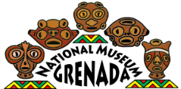  Grenada National Museum: Teacher Kit  Adventures Outside the Museum
Sickle Cell Anemia
Also in the Sauteurs Cemetery is the grave of Walter Clement Noel, the first ever diagnosed case of sickle-cell anemia. Sickle-cell is a genetic blood disorder characterized by abnormal, crescent-shaped blood cells. The disorder causes a number of blood-related problems and a shortened life span. However, in tropical climates where malaria is prevalent, the shape of these cells actually prevents malaria from infiltrating blood cells and hence, protects carriers from contracting malaria.

Over 100 years ago, in 1904, a boy by the name of Walter Clement Noel left Grenada to study dentistry in Chicago. He was 20 years old. After three months in Chicago, he came down with a severe flu and was admitted to the Chicago Presbyterian Hospital. The intern at the hospital treated Noel and took samples of his blood. Upon analysis, he told his supervisor, the cardiologist James B. Herrick, of the man’s strange looking blood. Herrick presumed it was the result of parasitic blood infection. No parasites were found, however, and Herrick began keeping track of the patient. Noel did not appear to be all that affected by the strange blood in his body, except that he got respiratory infections very easily. Noel was readmitted several times over the next three years for a variety of colds and coughs, but always recovered well. In 1907, he completed his studies, returned home, and established a dental practice in the town of St. George.
A few years later, in 1910, Dr. Herrick published a landmark paper about Noel’s "peculiar, elongated and sickle-shaped" blood cells. It’s now known to be the first, definitive case of
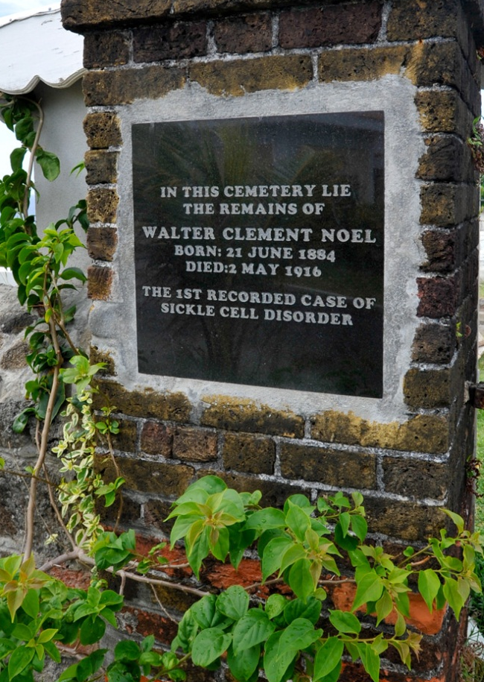
sickle-cell anemia.

As with other sufferers of sickle-cell, Walter Noel died of pneumonia in 1916, at the age of 32. He never learned of his disease, nor his contribution to medical history.

[Note that there is at least one other “Walter Noel” in the Sauteurs cemetery. Watch the dates on the tombstone to find the right one.]

