 | What is Archaeology?  Student Activity Handout: Crossword Puzzle (Extension) |  | Amerindian Heritage  Grenada National Museum: Teacher Kit
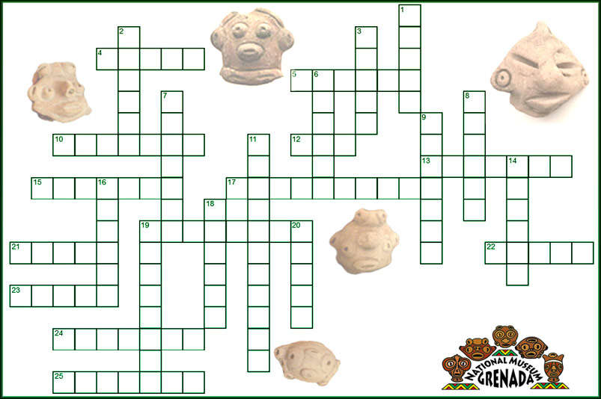
Instructions: Explore the museum exhibition and/or conduct research online for answers to these clues!
ACROSS
 | 4 | The dark, organic layer of soil on the surface.
 | 5 | Containing No. 18 Down, many Grenadians eat this porridge for breakfast.
 | 10 | The taking of artifacts without proper recording of their context, often to be sold illegally
 | 12* | "Orisha ___", meaning voo doo, an African "god of the head" used to enshrine the family spirit.
 | 13 | A fired clay object, commonly discovered and displayed as artifacts (examples include pottery, griddles, etc.)
 | 15 | A system of shared beliefs, meaning, and behavior by a group of people
 | 17 | A large stone carving left by Amerindians
 | 19* | A dark red type of clay used for pottery (2 words).
 | 21 | Another word for flint, the preferred stone for making tools
 | 22* | Feminine name for this "kicking" geologic structure, which may one day be her own island.
 | 23 | A stone fragment removed while making a stone tool, sometimes used as a tool in itself.
 | 24 | Called Rio _____, this delta is the source of the Saladoids who traveled here by at least 100 AD
 | 25 | Large, flat, ceramic plate for cooking manioc/cassava
 | DOWN
 | 1 | Term for an Amerindian house
 | 2* | Type of canoe made from the trunk of a silk cotton tree over 200 years ago; earlier versions played a large role in Amerindian migration and trade
 | 3 | Perhaps the most complex culture of Amerindians living in the prehistoric Caribbean, this group populated Puerto Rico and Hispaniola at the time of European contact.
 | 6 | Term for decorative attachments to pottery, often the faces of people and animals.
 | 7 | An important concept for archaeologists that considers the location of an item in a site, and its relationship with other items in time and space.
 | 8* | No. 12 Across is made of leather and this type of shell.
 | 9 | A general term for extremely ancient, pre-ceramic cultures. In the Caribbean, this "period" marks the use of primitive stone points, flakes, grinders, and other stone (and sometimes bone and shell) tools
 | 11 | A more "correct" name for the indigenous people of the Caribbean, though we may have known them by other names.
 | 14 | A term for an ancient trash deposit
 | 16 | Effigy dating to around 200 AD, colored red with white paint resembling a big reptile
 | 18 | Considered the staple crop of the Amerindian diet, this plentiful food was first domesticated in the Amazon over 10,000 years ago.
 | 19 | The name for the earliest ceramic (pottery-making) culture in the Caribbean. Their pottery is very distinct, often using white on red painting and crosshatching patterns.
 | 20 | A broken piece of ceramic
* Denotes the item in the clue may be in another part of the museum aside from the Archaeology displays.
 | Answer Key  Student Activity Handout: Crossword Puzzle (Extension) |  | Amerindian Heritage  Grenada National Museum: Teacher Kit

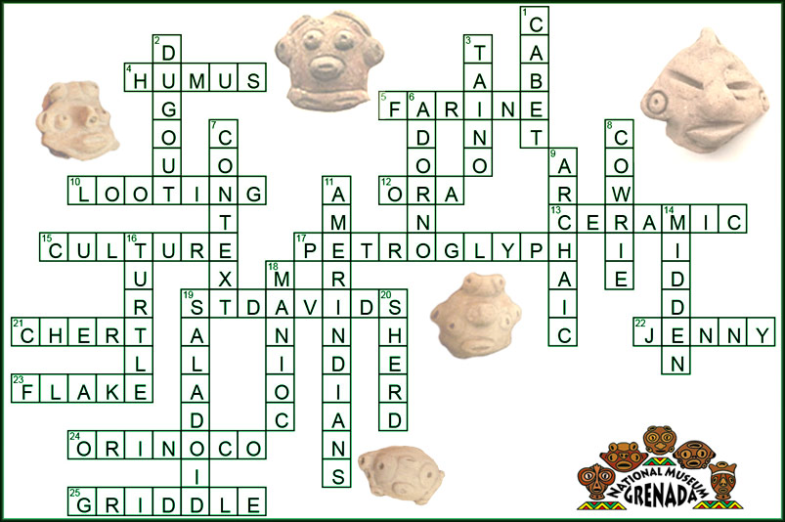

ACROSS
 | 4 | The dark, organic layer of soil on the surface.
 | 5 | Containing No. 18 Down, many Grenadians eat this porridge for breakfast.
 | 10 | The taking of artifacts without proper recording of their context, often to be sold illegally
 | 12* | "Orisha ___", meaning voo doo, an African "god of the head" used to enshrine the family spirit.
 | 13 | A fired clay object, commonly discovered and displayed as artifacts (examples include pottery, griddles, etc.)
 | 15 | A system of shared beliefs, meaning, and behavior by a group of people
 | 17 | A large stone carving left by Amerindians
 | 19* | A dark red type of clay used for pottery (2 words).
 | 21 | Another word for flint, the preferred stone for making tools
 | 22* | Feminine name for this "kicking" geologic structure, which may one day be her own island.
 | 23 | A stone fragment removed while making a stone tool, sometimes used as a tool in itself.
 | 24 | Called Rio _____, this delta is the source of the Saladoids who traveled here by at least 100 AD
 | 25 | Large, flat, ceramic plate for cooking manioc/cassava
 | DOWN
 | 1 | Term for an Amerindian house
 | 2* | Type of canoe made from the trunk of a silk cotton tree over 200 years ago; earlier versions played a large role in Amerindian migration and trade
 | 3 | Perhaps the most complex culture of Amerindians living in the prehistoric Caribbean, this group populated Puerto Rico and Hispaniola at the time of European contact.
 | 6 | Term for decorative attachments to pottery, often the faces of people and animals.
 | 7 | An important concept for archaeologists that considers the location of an item in a site, and its relationship with other items in time and space.
 | 8* | No. 12 Across is made of leather and this type of shell.
 | 9 | A general term for extremely ancient, pre-ceramic cultures. In the Caribbean, this "period" marks the use of primitive stone points, flakes, grinders, and other stone (and sometimes bone and shell) tools
 | 11 | A more "correct" name for the indigenous people of the Caribbean, though we may have known them by other names.
 | 14 | A term for an ancient trash deposit
 | 16 | Effigy dating to around 200 AD, colored red with white paint resembling a big reptile
 | 18 | Considered the staple crop of the Amerindian diet, this plentiful food was first domesticated in the Amazon over 10,000 years ago.
 | 19 | The name for the earliest ceramic (pottery-making) culture in the Caribbean. Their pottery is very distinct, often using white on red painting and crosshatching patterns.
 | 20 | A broken piece of ceramic
* Denotes the item in the clue may be in another part of the museum aside from the Archaeology displays.

