 | Handout: Amerindian Tools  Student museum activity: Examining and Comparing Tools |  | Amerindian Heritage  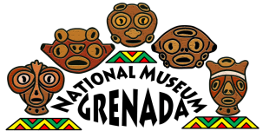  Grenada National Museum: Teacher Kit

Today, we’re going to explore some of the tools that Amerindians used to complete their everyday chores, like farming, hunting, building shelter, and making life easier for them on the island! Use this worksheet to investigate how some tools were used.
TOOL/OBJECT | Characteristics:
Size and Shape: __________________________________
Color:__________________________________________
What is it made of? ______________________________
Is it: __Heavy __Light Estimate its weight: _______lbs.
Other notes:____________________________________
_______________________________________________
Location Found:__________________________________
Date/Year Found: ________________________________
What was it used for? ____________________________
_______________________________________________
Name a modern-day tool that is similar:
_______________________________________________
Size and Shape: __________________________________
Color:__________________________________________
What is it made of? ______________________________
Is it: __Heavy __Light Estimate its weight: _______lbs.
Other notes:____________________________________
_______________________________________________
Location Found:__________________________________
Date/Year Found: ________________________________
What was it used for? ____________________________
_______________________________________________
Name a modern-day tool that is similar:
_______________________________________________

