 | Handout: Amerindian Tools  Sample images/drawings of tools |  | Amerindian Heritage  Grenada National Museum: Teacher Kit

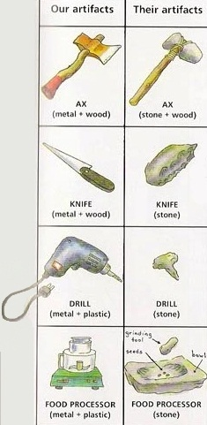
Some tools found in ancient archaeological sites tell us a lot about the people who lived there. Many of their tools are similar to ours, only they are made with different materials. What looks the same and what looks different among these tools?
Similarities:
AX:_____________________________________________________________________
KNIFE:___________________________________________________________________
DRILL:___________________________________________________________________
FOOD PROCESSOR (or mortar & pestle):________________________________________
________________________________________________________________________
Differences:
AX:_____________________________________________________________________
KNIFE:___________________________________________________________________
DRILL:___________________________________________________________________
FOOD PROCESSOR (or mortar & pestle):________________________________________
________________________________________________________________________
Artifacts discovered in the Caribbean
These tools are for digging fields and chopping wood and other things. |  | From Left to Right: a) knife, b) simple flaked tool, c) hammer-grinder, d) double-bitted ax, e) spearhead, f) shell gouge (for scooping and digging), and g) conical pestle (for grinding herbs, seeds, and other foods).
