 | Handout: Amerindian Foods  Student museum activity: Comparing our favorite foods |  | Amerindian Heritage  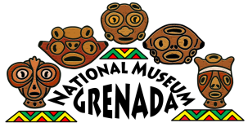  Grenada National Museum: Teacher Kit

What are some of your favorite foods?

Did you know many of our “favorite” foods were brought to the Caribbean by Amerindians? However, there are many other foods that were brought here by European colonialists
ACTIVITY: Circle one of your favorite foods from each group below. Then, answer the questions about them shown in the table.
Group A—Choose a favorite! (circle one) | Group B—Choose another favorite! (circle one)
Manioc  Maize/Corn  Beans  Papaya  Pineapple  Peanuts | Bananas  Oranges  Onions  Mangoes  Coconuts  Sugarcane
Sketch each item:

Write whether each item is a vegetable, fruit, plant, nut, seed, spice, or other:

How is each food commonly eaten? Raw? Cooked? Both?

Where or how do they grow? High on trees? Low to the ground? Underground? Describe:

Describe their color, size, weight, and shape. Are they full of juices, or very dry? Soft or hard?

Name 1 thing that is different about the items and 1 thing that is the same:

Did the Amerindians eat these items? Were they important for their survival? Are these items “easy” to grow in the Caribbean? Why?

This food is __From the New World ___From the Old World This food is __From the New World ___From the Old World
Bring this with you to the museum to find evidence and clues that support your answers.

